**Table of Contents:**

**1.0 Introduction 3**

**2.0 Audience 4**

**3.0 High Level Diagram 6**

**4.0 Main Subject Areas 7**

**5.0 Business Rules 9**

**5.1 In Scope Items 9**

**5.2 Out of Scope Items 11**

**6.0 Entities and Attributes12**

**7.0 Data Model32**

**8.0 Definition and Abbreviation36**

1. **Introduction:**

The objective of this project is to design Decision Support System for Dental Office that provide information about the dentist profile, patient information includes patient personal details, patient treatment, patient appointment, patient billing, and dental treatment and disease.

Dental Office is an organization that is responsible in providing a health medication and treatment for all types of dental patients. The traditional method means the customers need to fill in their details in registration form manually and the information will only keep in files. After the registration, the files will be placed in the rack and this will cause problems like taking a longer time to retrieve the information, make mistakes while writing or misplaced the files

Dental Office Management System is specially designed to let the clinic staff has a high efficiency management tools, computerized and systematic patient’s record, and detail of treatment records. This system also provide appointment feature, which allow staff to view the appointment that already made by dentist/Patient. Receptionist/Dentist can track all future appointments. Patient treatment module consists of the information about the tooth examination and record and list of treatment that has done. Apart from that, dental treatment and disease module provides information about the cause of tooth extraction and tooth filling.

The proposed system will save the effort and the time of patients from waiting to make the appointment as well as reduce the work of system administrator to access to information for report and easier to manage the appointment. The system administrator needs to maintain the records of patients. Patients should be able to know the availability of a particular date. They should be able to reserve the available rooms according to their needs in advance.

1. **Audiences**

**Admin**

* The role of the admin will be to enter and manage the system. He will be responsible for updating the data like if appointment is cancelled then change the status to cancel, if it is done then change the status to complete or done.
* All the database activities will e managed by the admin. Admin will be allowed to create new roles if required. He can increase or decrease the security of a table.
* Admin will play a main role in managing the system from data entry to data deletion and updating the data as per the requirement.

**Dentist**

* Apartment from admin, dentist will also be allowed to access the system.
* He/ She can check their appointments scheduled for a given date.
* He/ She can access the patient history and medical details with the help of the system. This will help the dentist to know more about the patient history before starting the treatment. He will get the details of the necessary precaution which needs to be taken before starting the treatment
* Dentist can also give prescription through the system directly to the patient without an appointment.
* He/ She will be informed about the license expiry, so that the Dentist can renew or make a new license.

**3.0 High Level Diagram**

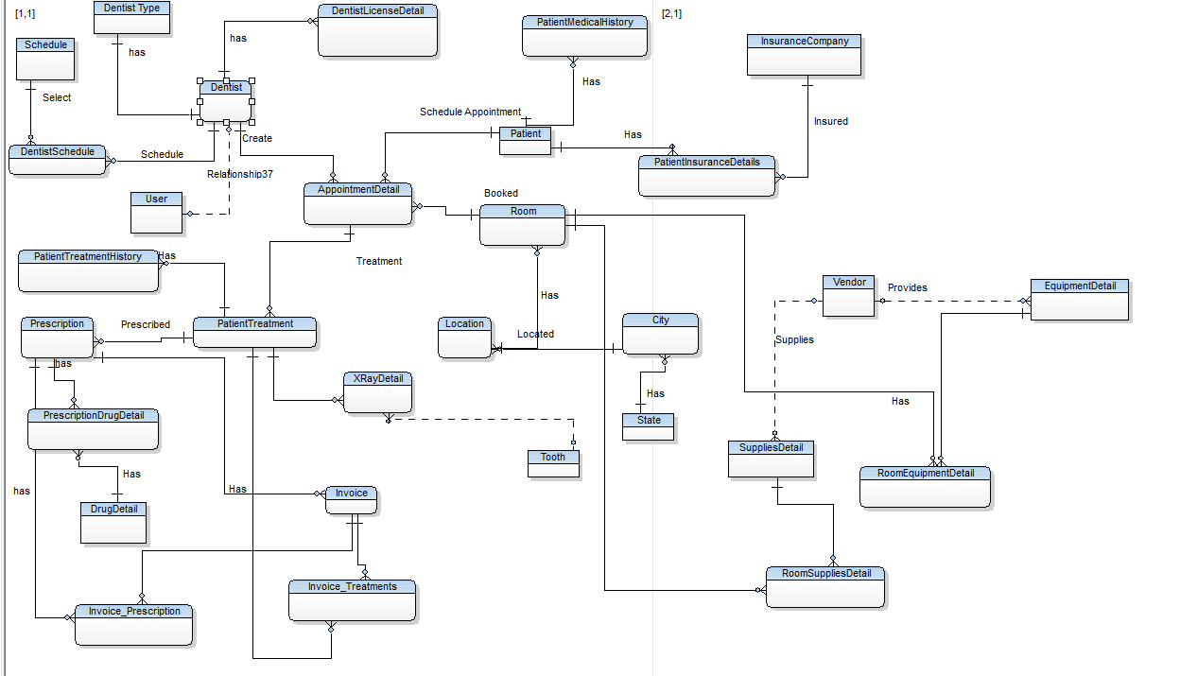

1. **Main Subject Areas**

**Patient**

* The Patient entity cluster will store all the information related to the patient identity like Patient ID, Patient Name, Address, Phone Number, E-Mail ID along with insurance details and medical history. This entity cluster will help in capturing all the information related to patient. Patient entity cluster will have a relationship with the dentist entity cluster with the help of appointment.

**Provider**

* The Provider entity cluster will store all the information about the dentist who will be operating on a patient. It will have information about the License a provider is having, years of experience, Provider ID, Provider name, etc. It will also store the insurance details and the appointment details. It will have a relationship with the appointment entity cluster as well as treatment entity cluster.

**Visit**

* This will have the details regarding the treatment which has been given to the patient during the current visit. It will also have details regarding any treatment taken from previous visits. Details regarding prescription given will also be stored in this entity cluster. Invoice will be generated based on the treatment given to the patient.

**Inventory**

* Inventory management will track the detail of all the supplies and equipment. It will track the cost and availability of all the Equipment and supplies. It will also record the contract details with a vendor such as a purchase contract or maintenance contract. Apart from this, the user can easily track the detail of any equipment such as where it is located, is it functioning properly or not, etc.

1. **Business Rules**
   1. **In Scope Items**

|  |  |  |
| --- | --- | --- |
| **ID** | **Business Rules** | **Area** |
| IS01 | The dentist will provide the treatment to one/many patients. | Dentist |
| IS02 | Dentist will provide the medical prescription to the patient | Dentist |
| IS03 | Dentist can treat a single patient at a time. | Dentist |
| IS04 | The Dentist Entity will store basic Information of Dentist such as Name, Phone Number, Address etc. | Dentist |
| IS05 | The Dentist can provide service to multiple location. | Dentist |
| IS06 | Every Dentist must have a valid license. | Dentist |
| IS07 | The Dentist can have one or multiple License according their specialization. | Dentist |
| IS08 | The Detail of license will be stored in License Detail Entity such as License Number, status, Type etc. | Dentist |
| IS09 | Confidential data such as SSN, Tax Payer Id, etc. should be stored in separate reference table with more security applied to the table. | Dentist |
| IS10 | The Specialization Entity will store the information of the doctor and detail of his/her specialization such as Dentist can be general dentist, orthodontist, prosthodontist etc. | Dentist |
| IS11 | Appointments booked by every patient will be recorded along with date, time and Dentist's details with whom the appointment is booked. | Dentist |
| IS12 | The patient Entity will store the basic detail of patient such as Name, Phone Number, and Emergency Number. | Patient |
| IS13 | Other Patient Details like missing teeth, facial growth problems, oral habit, spaced teeth etc. must be recorded in Patient’s health history. | Patient |
| IS14 | A patient can have more than one insurance. | Patient |
| IS15 | There cannot be multiple appointments at a single time for a patient. | Patient |
| IS16 | The system will store the details of various dental disease details. | Patient |
| IS17 | The system will store the detail of the treatment given by dentist to the patient. | Patient |
| IS18 | Patient can pay the bill via different payment mode and can set the preferred payment mode. | Patient |
| IS19 | The dentist can prescribe the drugs to the patient according to the disease. | Prescription |
| IS20 | The patient can get prescriptions from multiple dentists. | Prescription |
| IS21 | The Patient can change the payment mode and set the primary payment mode | Invoice |
| IS22 | The system will save the demographic information of the patient such as Address. | Patient |
| IS23 | A Patient can have one or more home addresses. | Patient |
| IS24 | Patient will have Emergency Contact Details | Patient |
| IS25 | Details regarding number of upper teeth and number of lower teeth of the patient must be recorded. | Patient |
| IS26 | Patient history must contain previous medical history. | Patient |
| IS27 | Multiple appointments can be made by a patient at multiple locations with different time | Appointment |
| IS28 | There is appointment status which will maintain the status of appointment such as Done, Cancelled etc. | Appointment |
| IS29 | An appointment must be associated with a specific location via a room | Appointment |
| IS30 | A room can be booked more than one time for different appointments. | Location |
| IS31 | Prescription provider name must be included in the prescription. | Prescription |
| IS32 | Treatment must have a treatment ID that can be used for invoice and dentist. | Treatment |
| IS33 | Details regarding which tooth has been treated during the treatment must be recorded. | Treatment |
| IS34 | The Dentist can send the prescription to the patient without having any appointment. | Prescription |
| IS35 | There is at least one invoice against the appointment | Invoice |
| IS36 | The Dentist can work with multiple schedule at multiple location | Dentist |
| IS37 | The Dentist can have one or more than one appointment in his/her working hours | Dentist |
| IS38 | The System will track the all the Equipment Details such as vendor detail, Is the equipment portable etc. | Equipment |
| IS39 | The Vendor Detail will save the all the information of Equipment / Supplies vendor | Vendor |
| IS40 | The System will track the information of all the available supplies | Supplies |
| IS41 | Supplies must contain supplier ID to track the shipment. | Supplies |
| IS42 | The System will track the contract details with Multiple vendors of equipment and supplies | Equipment |
| IS43 | We will track the details of the equipment such as where it is located currently | Equipment |
| IS44 | Medical equipment can be bought from multiple vendors. | Vendor |
| IS45 | Warranty details of equipment should be stored for repairing and replacement. | Equipment |

* 1. **Out of Scope Items**

|  |  |  |
| --- | --- | --- |
| **ID** | **Business Rules** | **Area** |
| OS01 | Feedback for dentist is not tracked. | Dentist |
| OS02 | Salaries of dentist and staff are not tracked in the system | Dentist |
| OS03 | Schedule of staff working in the office is not captured. | Other Staff |
| OS04 | Other staff working in office but not participating in the dental care of the patient are not tracked. | Other Staff |
| OS05 | Cost of the prescribed medicines are not tracked in the system. | Medicine |
| OS06 | Utilities that are being used in the room are not tracked. | Location |
| OS07 | Finances of Dentist office are not tracked. | Dentist |
| OS08 | Medicines for other diseases apart from dental problems, | Medicine |
| OS09 | No method for membership plans/discounts to the regular patients at this dental office. | Membership |
| OS10 | Status of prescription is not required. | Prescription |

1. **Entities and Attributes**
2. **Master Tables**

* **City Table**

|  |  |  |  |
| --- | --- | --- | --- |
| **Attribute_ID** | **DataType** | **Constraints** | **Definition with example** |
| City_Code | Char (4) | Primary Key (PK),  Not Null (NN) | A City code to differentiate Different Cities in a table. Example. 01,02 |
| City_Name | Varchar (50) | Not Null (NN) | Name of the city. For example, Boston, New York. |
| State_Code | Integer | Foreign Key, Not Null (NN) |  |
| Created_By | Integer | Not Null (NN) | The data created by example 1,2,3 |
| Created_Time | DateTime | Not Null (NN) | The data created time example 12/10/2019 12:00:00 |
| Modified_By | Integer | Not Null (NN) | The data modified by example 4,5,6 |
| Modified_Time | DateTime | Not Null (NN) | The data modified time example 12/11/2019 13:10:00 |

* **State Table**

|  |  |  |  |
| --- | --- | --- | --- |
| **Attribute_ID** | **DataType** | **Constraints** | **Definition with example** |
| State_Code | Char (4) | Primary Key (PK),  Not Null (NN) | A State code to differentiate Different State in a table. Example. 01,02 |
| State_Name | Varchar (50) | Not Null (NN) | Name of the State. For example, Texas, Massachusetts. |
| Created_By | Integer | Not Null (NN) | The data created by example 1,2,3 |
| Created_Time | DateTime | Not Null (NN) | The data created time example 12/10/2019 12:00:00 |
| Modified_By | Integer | Not Null (NN) | The data modified by example 4,5,6 |
| Modified_Time | DateTime | Not Null (NN) | The data modified time example 12/11/2019 13:10:00 |

* **Insurance Company**

|  |  |  |  |
| --- | --- | --- | --- |
| **Attribute_ID** | **DataType** | **Constraints** | **Definition with example** |
| Insurance_  Company_Id | Integer | Primary Key (PK),  Not Null (NN) | A State code to differentiate Different State in a table. Example. 01,02 |
| State_Name | Varchar (50) | Not Null (NN) | Name of the State. For example, Texas, Massachusetts. |
| Created_By | Integer | Not Null (NN) | The data created by example 1,2,3 |
| Created_Time | DateTime | Not Null (NN) | The data created time example 12/10/2019 12:00:00 |
| Modified_By | Integer | Not Null (NN) | The data modified by example 4,5,6 |
| Modified_Time | DateTime | Not Null (NN) | The data modified time example 12/11/2019 13:10:00 |

* **Tooth**

|  |  |  |  |
| --- | --- | --- | --- |
| **Attribute_ID** | **DataType** | **Constraints** | **Definition with example** |
| Tooth_Id | Integer | Primary Key (PK),  Not Null (NN) | A unique Id to differentiate between different tooth. Example 1,2,3 |
| Tooth_  Description | Varchar (200) | Not Null (NN) | Description about tooth. Example canine tooth |
| Tooth_File_  Path | Varchar  (200) | Not Null (NN) | Tooth file path contains the image path of a tooth. |
| Created_Time | DateTime | Not Null (NN) | The data created time example 12/10/2019 12:00:00 |
| Modified_By | Integer | Not Null (NN) | The data modified by example 4,5,6 |
| Modified_Time | DateTime | Not Null (NN) | The data modified time example 12/11/2019 13:10:00 |

* **Location**

|  |  |  |  |
| --- | --- | --- | --- |
| **Attribute_ID** | **DataType** | **Constraints** | **Definition with example** |
| Location_Id | Integer | Primary Key (PK),  Not Null (NN) | A unique Id to differentiate between different Location. Example 1,2,3 |
| Location_  Name | Varchar (100) | Not Null (NN) | Name of a Location. Example Washington Street |
| Location_  Address | Varchar  (200) | Not Null (NN) | Location address. Example 115 Northampton Street |
| State_Code | Integer | Foreign Key (FK), Not Null (NN) |  |
| City_Code | Integer | Foreign Key (FK), Not Null (NN) |  |
| Zip_Code | Integer | Not Null (NN) | Zip code of a location. Example, 02118 |
| Created_Time | DateTime | Not Null (NN) | The data created time example 12/10/2019 12:00:00 |
| Modified_By | Integer | Not Null (NN) | The data modified by example 4,5,6 |
| Modified_Time | DateTime | Not Null (NN) | The data modified time example 12/11/2019 13:10:00 |

* **Room**

|  |  |  |  |
| --- | --- | --- | --- |
| **Attribute_ID** | **DataType** | **Constraints** | **Definition with example** |
| Room_Id | Integer | Primary Key (PK),  Not Null (NN) | A unique Id to differentiate between different Room. Example 1,2,3 |
| Room_Name | Varchar (50) | Null (N) | Name of a Room. Example Tulip |
| Location_Id | Integer | Foreign Key (FK), Not Null (NN) |  |
| Room_Number | Integer | Not Null (NN) | Number of a room. Example 202 |
| Floor | Small Integer | Not Null (NN) | Floor number. Example First, Second Floor |
| Created_Time | DateTime | Not Null (NN) | The data created time example 12/10/2019 12:00:00 |
| Modified_By | Integer | Not Null (NN) | The data modified by example 4,5,6 |
| Modified_Time | DateTime | Not Null (NN) | The data modified time example 12/11/2019 13:10:00 |

* **Vendor**

|  |  |  |  |
| --- | --- | --- | --- |
| **Attribute_ID** | **DataType** | **Constraints** | **Definition with example** |
| Vendor_Id | Integer | Primary Key (PK),  Not Null (NN) | A unique Id to differentiate between different Vendors. Example 1,2,3 |
| Vendor_Name | Varchar (50) | Not Null (NN) | Name of the Vendor. For example, Afrojack. |
| Created_By | Integer | Not Null (NN) | The data created by example 1,2,3 |
| Created_Time | DateTime | Not Null (NN) | The data created time example 12/10/2019 12:00:00 |
| Modified_By | Integer | Not Null (NN) | The data modified by example 4,5,6 |
| Modified_Time | DateTime | Not Null (NN) | The data modified time example 12/11/2019 13:10:00 |

* **Drug Details**

|  |  |  |  |
| --- | --- | --- | --- |
| **Attribute_ID** | **DataType** | **Constraints** | **Definition with example** |
| Drug_detail_Id | Integer | Primary Key (PK),  Not Null (NN) | A unique Id to differentiate between different Drug Details. Example 1,2,3 |
| Drug_Name | Varchar (50) | Not Null (NN) | Name of the Drug. For example, Paracetamol. |
| Drug_type | Varchar  (10) | Not Null (NN) | Type of Drug. Example High Dose |
| Drug_  Description | Varchar  (200) | Not Null (NN) | Description about Drugs. Example Paracetamol is for cold and cough. |
| Created_By | Integer | Not Null (NN) | The data created by example 1,2,3 |
| Created_Time | DateTime | Not Null (NN) | The data created time example 12/10/2019 12:00:00 |
| Modified_By | Integer | Not Null (NN) | The data modified by example 4,5,6 |
| Modified_Time | DateTime | Not Null (NN) | The data modified time example 12/11/2019 13:10:00 |

1. **Transaction tables**

* **Dentist**

|  |  |  |  |
| --- | --- | --- | --- |
| **Attribute_ID** | **DataType** | **Constraints** | **Definition with example** |
| Dentist_Id | Integer | Primary Key (PK),  Not Null (NN) | A unique Id to differentiate between different Dentist. Example 1,2,3 |
| First_Name | Varchar (50) | Not Null (NN) | First Name of the Dentist. For example, Jack. |
| Middle_Name | Varchar  (50) | Null (N) | Middle Name of the dentist. For example, J. |
| Last_Name | Varchar  (50) | Not Null (NN) | Last Name of the dentist. For Example, Ryan. |
| Dentist_SSN | Varchar  (10) | Not Null (NN) | SSN number of a dentist. Example, 1QAW23S34 |
| Dentist_  Gender | Varchar  (5) | Not Null (NN) | Gender of a dentist. Example, Male |
| Dentist_Phone | Varchar  (10) | Not Null (NN) | Phone number of dentists. Example, 8578005124 |
| Dentist_Type  _Id | Integer | Foreign Key (FK), Not Null (NN) |  |
| Dentist_Work  _Experience | Integer | Not Null (NN) | Work experience of a Dentist. Example 2 |
| Created_By | Integer | Not Null (NN) | The data created by example 1,2,3 |
| Created_Time | DateTime | Not Null (NN) | The data created time example 12/10/2019 12:00:00 |
| Modified_By | Integer | Not Null (NN) | The data modified by example 4,5,6 |
| Modified_Time | DateTime | Not Null (NN) | The data modified time example 12/11/2019 13:10:00 |

* **Dentist Type**

|  |  |  |  |
| --- | --- | --- | --- |
| **Attribute_ID** | **DataType** | **Constraints** | **Definition with example** |
| Dentist_type_  Id | Integer | Primary Key (PK),  Not Null (NN) | A unique Id to differentiate between different Dentist  Type. Example 1,2,3 |
| Dentist_Type_  Name | Varchar (50) | Not Null (NN) | Name of Dentist Type. Example Ortho surgeon |
| Dentist_Type_  Description | Varchar  (200) | Not Null (NN) | Description About Dentist Type. Example, Ortho surgeon is for maintaining the care for teeth. |
| Created_Time | DateTime | Not Null (NN) | The data created time example 12/10/2019 12:00:00 |
| Modified_By | Integer | Not Null (NN) | The data modified by example 4,5,6 |
| Modified_Time | DateTime | Not Null (NN) | The data modified time example 12/11/2019 13:10:00 |

* **Dentist License Details**

|  |  |  |  |
| --- | --- | --- | --- |
| **Attribute_ID** | **DataType** | **Constraints** | **Definition with example** |
| Dentist_License  _Number | Integer | Primary Key (PK),  Not Null (NN) | A unique Id to differentiate between different Dentist. Example 1,2,3 |
| Dentist_Id | Integer | Foreign Key (FK)Not Null (NN) |  |
| License_Expire  _Date | DateTime | Null (N) | License Expire Date. Example, 12/10/2019 |
| Created_Time | DateTime | Not Null (NN) | The data created time example 12/10/2019 12:00:00 |
| Modified_By | Integer | Not Null (NN) | The data modified by example 4,5,6 |
| Modified_Time | DateTime | Not Null (NN) | The data modified time example 12/11/2019 13:10:00 |

* **Schedule**

|  |  |  |  |
| --- | --- | --- | --- |
| **Attribute_ID** | **DataType** | **Constraints** | **Definition with example** |
| Schedule_Id | Integer | Primary Key (PK),  Not Null (NN) | A unique Id to differentiate between different Schedule. Example 1,2,3 |
| Start_Time | DateTime | Not Null (NN) | Schedule Starting Time. Example 12/10/201912:10:00 |
| End_Time | DateTime | Not Null (NN) | Schedule ending time. Example, 12/23/2019 13:00:09 |
| Created_Time | DateTime | Not Null (NN) | The data created time example 12/10/2019 12:00:00 |
| Modified_By | Integer | Not Null (NN) | The data modified by example 4,5,6 |
| Modified_Time | DateTime | Not Null (NN) | The data modified time example 12/11/2019 13:10:00 |

* **Dentist schedule Table**

|  |  |  |  |
| --- | --- | --- | --- |
| **Attribute_ID** | **DataType** | **Constraints** | **Definition with example** |
| Dentist_Schedule  _Id | Integer | Primary Key (PK),  Not Null (NN) | A unique Id to differentiate between different Dentist schedule. Example 1,2,3 |
| Dentist_Id | Integer | Foreign Key (FK)Not Null (NN) |  |
| Schedule_Id | Integer | Foreign Key (FK)Not Null (NN) |  |
| Created_Time | DateTime | Not Null (NN) | The data created time example 12/10/2019 12:00:00 |
| Modified_By | Integer | Not Null (NN) | The data modified by example 4,5,6 |
| Modified_Time | DateTime | Not Null (NN) | The data modified time example 12/11/2019 13:10:00 |

* **Patient**

|  |  |  |  |
| --- | --- | --- | --- |
| **Attribute_ID** | **DataType** | **Constraints** | **Definition with example** |
| Patient_Id | Integer | Primary Key (PK),  Not Null (NN) | A unique Id to differentiate between different Patient. Example 1,2,3 |
| First_Name | Varchar (50) | Not Null (NN) | First Name of the Patient. For example, Jack. |
| Middle_Name | Varchar  (50) | Null (N) | Middle Name of the Patient. For example, J. |
| Last_Name | Varchar  (50) | Not Null (NN) | Last Name of the Patient. For Example, Ryan. |
| Date_Of_Birth | Integer | Not Null (NN) | Date of Birth of a patient. Example, 12/10/2019 |
| Patient_  Address | Varchar  (5) | Not Null (NN) | Address of a patient. For Example, 115 Northampton Street. |
| State_Code | Integer | Foreign Key (FK), Not Null (NN) |  |
| City_Code | Integer | Foreign Key (FK), Not Null (NN) |  |
| Zip_Code | Integer | Not Null (NN) | Zip code of patient. Example, 02118 |
| Patient_  Emergency_  Contact_  Number | Varchar  (10) | Not Null  (NN) | Emergency contact number of a patient. Example, 8578444512 |
| Patient_  Emergency  _Contact_  Name | Varchar  (50) | Not Null  (NN) | Emergency contact name of a patient. Example, Yash |
| Patient_Age | Integer | Not Null  (NN) | Calculated Field through Date of Birth. Example, 23 |
| Created_By | Integer | Not Null (NN) | The data created by example 1,2,3 |
| Created_Time | DateTime | Not Null (NN) | The data created time example 12/10/2019 12:00:00 |
| Modified_By | Integer | Not Null (NN) | The data modified by example 4,5,6 |
| Modified_Time | DateTime | Not Null (NN) | The data modified time example 12/11/2019 13:10:00 |

* **Patient Medical History**

|  |  |  |  |
| --- | --- | --- | --- |
| **Attribute_ID** | **DataType** | **Constraints** | **Definition with example** |
| Patient_  Medical_History  _Id | Integer | Primary Key (PK),  Not Null (NN) | A unique Id to differentiate between different Patient medical history. Example 1,2,3 |
| Patient_Id | Integer | Foreign Key (FK)Not Null (NN) |  |
| Patient_  Allregry_Details | Varchar  (250) | Not Null (NN) | Allergy Details of a patient. Example itching in skin. |
| Other_Diseases | Varchar  (250) | Not Null (NN) | Other diseases that patient has. Example cough cold |
| Patient_Medical  _Report_File  _Path | Varchar  (200) | Not Null (NN) | Location where medical report of a patient is kept. |
| Created_Time | DateTime | Not Null (NN) | The data created time example 12/10/2019 12:00:00 |
| Modified_By | Integer | Not Null (NN) | The data modified by example 4,5,6 |
| Modified_Time | DateTime | Not Null (NN) | The data modified time example 12/11/2019 13:10:00 |

* **Patient Insurance Details**

|  |  |  |  |
| --- | --- | --- | --- |
| **Attribute_ID** | **DataType** | **Constraints** | **Definition with example** |
| Patient_  Insurance_  Details_Id | Integer | Primary Key (PK),  Not Null (NN) | A unique Id to differentiate between different Patient Insurance details. Example 1,2,3 |
| Patient_Id | Integer | Foreign Key (FK)Not Null (NN) |  |
| Insurance_  Number | Integer | Not Null (NN) | Patient health Insurance number. Example 642318 |
| Insurance_  Cover_Amount | Money | Not Null (NN) | Patient insurance cover amount. Example $23456 |
| Insurance_  Company_Id | Integer | Foreign Key (FK), Not Null (NN) |  |
| Created_Time | DateTime | Not Null (NN) | The data created time example 12/10/2019 12:00:00 |
| Modified_By | Integer | Not Null (NN) | The data modified by example 4,5,6 |
| Modified_Time | DateTime | Not Null (NN) | The data modified time example 12/11/2019 13:10:00 |

* **Equipment Details**

|  |  |  |  |
| --- | --- | --- | --- |
| **Attribute_ID** | **DataType** | **Constraints** | **Definition with example** |
| Equipment_  Detail_Id | Integer | Primary Key (PK),  Not Null (NN) | A unique Id to differentiate between different Equipment Details. Example 1,2,3 |
| Equipment_  Name | Varchar  (100) | Not Null (NN) | Name of the equipment. Example Forceps |
| Equipment_  Type | Varchar  (10) | Not Null (NN) | Type of Equipment Used. Example ting |
| Is_Portable | Boolean | Not Null (NN) | Can Equipment be moved from place to place? Example Yes |
| Vendor_Id | Integer | Foreign Key (FK), Not Null (NN) |  |
| Contract_End  _Date | DateTime | Not Null  (NN) | Date at which contract ends. Example 12/10/2019 |
| Equipement_  Total_Quantity | Integer | Not Null  (NN) | Total Quantity of Equipment. Example 20 |
| Equipment_  Description | Varchar  (200) | Not Null  (NN) | Description of equipment. Example It is used for treatment. |
| Created_Time | DateTime | Not Null (NN) | The data created time example 12/10/2019 12:00:00 |
| Modified_By | Integer | Not Null (NN) | The data modified by example 4,5,6 |
| Modified_Time | DateTime | Not Null (NN) | The data modified time example 12/11/2019 13:10:00 |

* **Room Equipment Details**

|  |  |  |  |
| --- | --- | --- | --- |
| **Attribute_ID** | **DataType** | **Constraints** | **Definition with example** |
| Room_  Equipment  _Details_Id | Integer | Primary Key (PK),  Not Null (NN) | A unique Id to differentiate between different Room equipment details. Example 1,2,3 |
| Room_Id | Integer | Foreign Key (FK)Not Null (NN) |  |
| Equipment_  Detail_Id | Integer | Foreign Key (FK)Not Null (NN) |  |
| Equipment  _Quantity | Integer | Not Null (NN) | Number of equipment used. Example 24 |
| Created_Time | DateTime | Not Null (NN) | The data created time example 12/10/2019 12:00:00 |
| Modified_By | Integer | Not Null (NN) | The data modified by example 4,5,6 |
| Modified_Time | DateTime | Not Null (NN) | The data modified time example 12/11/2019 13:10:00 |

* **Supplies Details**

|  |  |  |  |
| --- | --- | --- | --- |
| **Attribute_ID** | **DataType** | **Constraints** | **Definition with example** |
| Supplies  _Details_Id | Integer | Primary Key (PK),  Not Null (NN) | A unique Id to differentiate between different Supplies details. Example 1,2,3 |
| Supplies_Name | Varchar  (50) | Not Null (NN) | Name of the supplies. |
| Supplies_  Description | Varchar  (200) | Not Null (NN) | Description about supplies. |
| Total_Quantity | Integer | Not Null (NN) | Number of Supplies used. Example 24 |
| Vendor_Id | Integer | Foreign Key (FK), Not Null  (NN) |  |
| Created_Time | DateTime | Not Null (NN) | The data created time example 12/10/2019 12:00:00 |
| Modified_By | Integer | Not Null (NN) | The data modified by example 4,5,6 |
| Modified_Time | DateTime | Not Null (NN) | The data modified time example 12/11/2019 13:10:00 |

* **Room Supplies Details**

|  |  |  |  |
| --- | --- | --- | --- |
| **Attribute_ID** | **DataType** | **Constraints** | **Definition with example** |
| Room_  Supplies  _Details_Id | Integer | Primary Key (PK),  Not Null (NN) | A unique Id to differentiate between different Room Supplies details. Example 1,2,3 |
| Room_Id | Integer | Foreign Key (FK)Not Null (NN) |  |
| Equipment_  Detail_Id | Integer | Foreign Key (FK)Not Null (NN) |  |
| Quantity | Integer | Not Null (NN) | Number of Quantity used. Example 24 |
| Created_Time | DateTime | Not Null (NN) | The data created time example 12/10/2019 12:00:00 |
| Modified_By | Integer | Not Null (NN) | The data modified by example 4,5,6 |
| Modified_Time | DateTime | Not Null (NN) | The data modified time example 12/11/2019 13:10:00 |

* **Appointment**

|  |  |  |  |
| --- | --- | --- | --- |
| **Attribute_ID** | **DataType** | **Constraints** | **Definition with example** |
| Appointment  _Id | Integer | Primary Key (PK),  Not Null (NN) | A unique Id to differentiate between different appointment. Example 1,2,3 |
| Dentist_Id | Integer | Foreign Key (FK), Not Null (NN) |  |
| Patient_Id | Integer | Foreign Key (FK), Not Null (NN) |  |
| Room_Id | Integer | Foreign Key (FK), Not Null (NN) |  |
| Appointment  _Start_Time | Date Time | Not Null  (NN) | Appointment Start time. Example 12/10/2019 12:20:00 |
| Appointment  _End_Time | Date Time | Not Null  (NN) | Appointment End time. Example 12/11/2019 13:25:00 |
| Created_Time | DateTime | Not Null (NN) | The data created time example 12/10/2019 12:00:00 |
| Modified_By | Integer | Not Null (NN) | The data modified by example 4,5,6 |
| Modified_Time | DateTime | Not Null (NN) | The data modified time example 12/11/2019 13:10:00 |

* **Patient Treatment**

|  |  |  |  |
| --- | --- | --- | --- |
| **Attribute_ID** | **DataType** | **Constraints** | **Definition with example** |
| Patient_  Treatment_Id | Integer | Primary Key (PK),  Not Null (NN) | A unique Id to differentiate between different Patient Treatment. Example 1,2,3 |
| Appointment  _Details_Id | Integer | Foreign Key (FK), Not Null (NN) |  |
| Treatment_  Comment | Varchar  (500) | Not Null  (NN) | Comment about treatment. |
| Created_Time | DateTime | Not Null (NN) | The data created time example 12/10/2019 12:00:00 |
| Modified_By | Integer | Not Null (NN) | The data modified by example 4,5,6 |
| Modified_Time | DateTime | Not Null (NN) | The data modified time example 12/11/2019 13:10:00 |

* **X-ray Details**

|  |  |  |  |
| --- | --- | --- | --- |
| **Attribute_ID** | **DataType** | **Constraints** | **Definition with example** |
| X-ray  _Details_Id | Integer | Primary Key (PK),  Not Null (NN) | A unique Id to differentiate between different X-ray. Example 1,2,3 |
| Patient_  Treatment_Id | Integer | Foreign Key (FK), Not Null (NN) |  |
| Tooth_Id | Integer | Foreign Key (FK), Not Null (NN) |  |
| X-ray_File  _path | Varchar  (200) | Not Null (NN) | Path where X-rays are kept. |
| Created_Time | DateTime | Not Null (NN) | The data created time example 12/10/2019 12:00:00 |
| Modified_By | Integer | Not Null (NN) | The data modified by example 4,5,6 |
| Modified_Time | DateTime | Not Null (NN) | The data modified time example 12/11/2019 13:10:00 |

* **Patient Treatment History**

|  |  |  |  |
| --- | --- | --- | --- |
| **Attribute_ID** | **DataType** | **Constraints** | **Definition with example** |
| Patient_  Treatment_  History_Id | Integer | Primary Key (PK),  Not Null (NN) | A unique Id to differentiate between different Patient Treatment history. Example 1,2,3 |
| Patient_  Treatment_Id | Integer | Foreign Key (FK), Not Null (NN) |  |
| Appointment  _Details_Id | Integer | Foreign Key (FK), Not Null (NN) |  |
| Treatment_  Comment | Varchar  (200) | Not Null (NN) | Comment about treatment. |
| Created_Time | DateTime | Not Null (NN) | The data created time example 12/10/2019 12:00:00 |
| Modified_By | Integer | Not Null (NN) | The data modified by example 4,5,6 |
| Modified_Time | DateTime | Not Null (NN) | The data modified time example 12/11/2019 13:10:00 |

* **Prescription**

|  |  |  |  |
| --- | --- | --- | --- |
| **Attribute_ID** | **DataType** | **Constraints** | **Definition with example** |
| Prescription_Id | Integer | Primary Key (PK),  Not Null (NN) | A unique Id to differentiate between different Prescritpion. Example 1,2,3 |
| Patient_  Treatment_Id | Integer | Foreign Key (FK), Not Null (NN) |  |
| Dentist Comment | Varchar  (200) | Not Null (NN) | Dentist prescription comments. |
| Created_Time | DateTime | Not Null (NN) | The data created time example 12/10/2019 12:00:00 |
| Modified_By | Integer | Not Null (NN) | The data modified by example 4,5,6 |
| Modified_Time | DateTime | Not Null (NN) | The data modified time example 12/11/2019 13:10:00 |

* **Prescription Drug Details**

|  |  |  |  |
| --- | --- | --- | --- |
| **Attribute_ID** | **DataType** | **Constraints** | **Definition with example** |
| Prescription  _Drug_  Details_Id | Integer | Primary Key (PK),  Not Null (NN) | A unique Id to differentiate between different Drug  Details. Example 1,2,3 |
| Prescription_Id | Integer | Foreign Key (FK), Not Null (NN) |  |
| Drug_Id | Integer | Foreign Key (FK), Not Null (NN) |  |
| Drug_Quntity | Integer | Not Null (NN) | Drug quantity provided by doctor for treatment. Example 3 |
| Created_Time | DateTime | Not Null (NN) | The data created time example 12/10/2019 12:00:00 |
| Modified_By | Integer | Not Null (NN) | The data modified by example 4,5,6 |
| Modified_Time | DateTime | Not Null (NN) | The data modified time example 12/11/2019 13:10:00 |

* **Invoice**

|  |  |  |  |
| --- | --- | --- | --- |
| **Attribute_ID** | **DataType** | **Constraints** | **Definition with example** |
| Invoice_Id | Integer | Primary Key (PK),  Not Null (NN) | A unique Id to differentiate between different Invoice. Example 1,2,3 |
| Description | Varchar  (200) | Not Null (NN) | Description about payment. |
| Final_Amount | Varchar  (50) | Not Null (NN) | Final amount in Invoice. Example $243 |
| Created_Time | DateTime | Not Null (NN) | The data created time example 12/10/2019 12:00:00 |
| Modified_By | Integer | Not Null (NN) | The data modified by example 4,5,6 |
| Modified_Time | DateTime | Not Null (NN) | The data modified time example 12/11/2019 13:10:00 |

* **Invoice Prescription**

|  |  |  |  |
| --- | --- | --- | --- |
| **Attribute_ID** | **DataType** | **Constraints** | **Definition with example** |
| Invoice_  Prescription_Id | Integer | Primary Key (PK),  Not Null (NN) | A unique Id to differentiate between different Prescription. Example 1,2,3 |
| Prescription_Id | Integer | Foreign Key (FK), Not Null (NN) |  |
| Invoice_Id | Integer | Foreign Key (FK), Not Null (NN) |  |
| Created_Time | DateTime | Not Null (NN) | The data created time example 12/10/2019 12:00:00 |
| Modified_By | Integer | Not Null (NN) | The data modified by example 4,5,6 |
| Modified_Time | DateTime | Not Null (NN) | The data modified time example 12/11/2019 13:10:00 |

* **Invoice Treatment**

|  |  |  |  |
| --- | --- | --- | --- |
| **Attribute_ID** | **DataType** | **Constraints** | **Definition with example** |
| Invoice_  Treatment_Id | Integer | Primary Key (PK),  Not Null (NN) | A unique Id to differentiate between different Prescription treatment. Example 1,2,3 |
| Patient_  Treatment_Id | Integer | Foreign Key (FK), Not Null (NN) |  |
| Invoice_Id | Integer | Foreign Key (FK), Not Null (NN) |  |
| Created_Time | DateTime | Not Null (NN) | The data created time example 12/10/2019 12:00:00 |
| Modified_By | Integer | Not Null (NN) | The data modified by example 4,5,6 |
| Modified_Time | DateTime | Not Null (NN) | The data modified time example 12/11/2019 13:10:00 |

* **User**

|  |  |  |  |
| --- | --- | --- | --- |
| **Attribute_ID** | **DataType** | **Constraints** | **Definition with example** |
| User_Id | Integer | Primary Key (PK),  Not Null (NN) | A unique Id to differentiate between different Users. Example 1,2,3 |
| User_Name | Varchar  (100) | Not Null (NN) | User name to login into system. |
| Password | Varchar  (50) | Not Null (NN) | Password to enter into system. |
| Role_Name | Varchar  (50) | Not Null (NN) | Name of the role which is used to get into system. Example Dentist, Patient |
| Is_Active | Boolean | Not Null (NN) | To check is the user is still active. Example Yes |
| Last_Login_  Date_Time | DateTime | Not Null (NN) | Date and Time of previous login of a user. |
| Created_Time | DateTime | Not Null (NN) | The data created time example 12/10/2019 12:00:00 |
| Modified_By | Integer | Not Null (NN) | The data modified by example 4,5,6 |
| Modified_Time | DateTime | Not Null (NN) | The data modified time example 12/11/2019 13:10:00 |

1. **Data Model**

**Dentist Cluster**

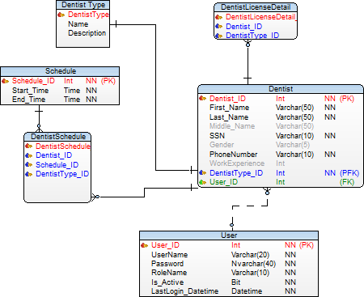

**Inventory Cluster**

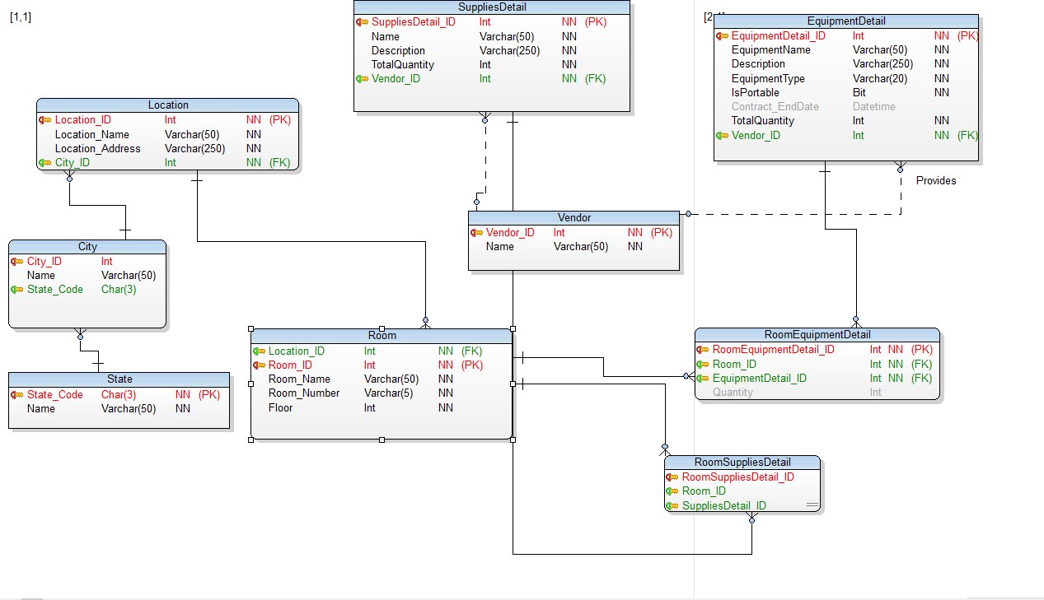

**Patient Cluster**

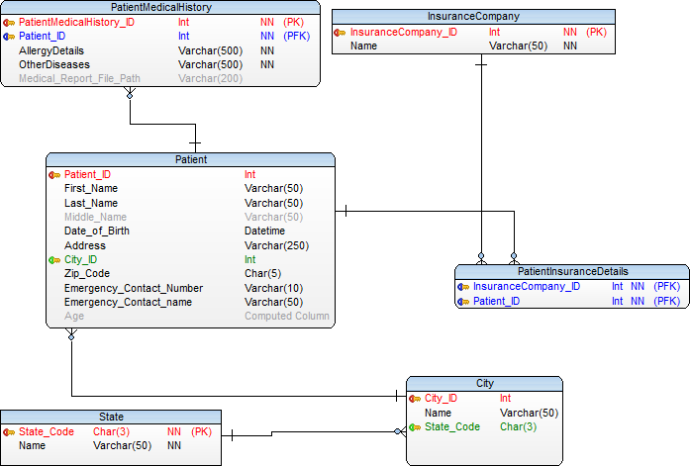

**Treatment Cluster**

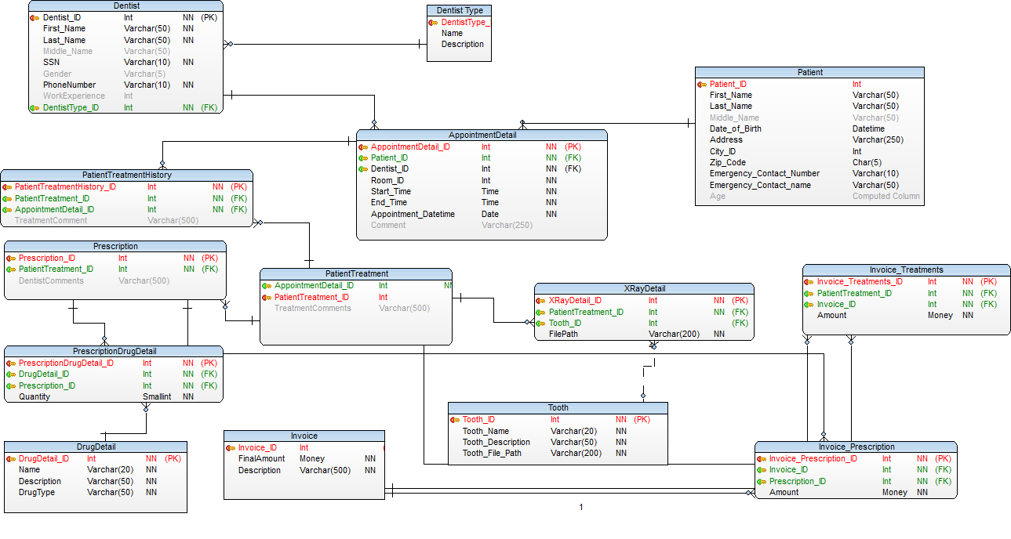

**8.0 Definition and Abbreviation**

PK : Primary Key

FK : Foreign Key

NN : Not Null

PFK : Primary Foreign Key

N : Null